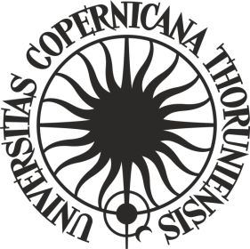**RESOLUTION No. 8**

**of the Senate of the Nicolaus Copernicus University in Toruń**

of 28 January 2020

**amending resolution No. 89 of the NCU Senate of 25 June 2019 on the proceedings for the award of the degree of doktor at the Nicolaus Copernicus University in Toruń**

Pursuant to art. 192.2 and 192.3 of the Act of 20 July 2018 - Law on Higher Education and Science (Dz.U. of 2018, item 1668 as amended) and art. 48.25 and 48.27 of the Statutes of the Nicolaus Copernicus University in Toruń of 16 April 2019 (Biuletyn Prawny UMK of 2019, item 120)

**i t i s r e s o l v e d** as follows:

Article 1

The following point (6) shall be added to art. 20 in Resolution No. 89 of the NCU Senate of 25 June 2019 on the proceedings for the award of the degree of doktor at the Nicolaus Copernicus University in Toruń (Biuletyn Prawny UMK   
of 2019, item 210 as amended):

**„Article 20**

**6. In the assessment process and proceedings for the promotion in scientific research initiated by 30 April 2019 and not closed by 30 September 2019, the existing provisions shall apply, i.e. bearing in mind the provisions resulting from the Act of 14 March 2003 - Law on Academic Degrees and Title and Degrees and Title in the Arts, in which case after 1 October 2019 the degree shall be awarded by the Council for the Discipline of Science. The voting shall be secret and the resolutions shall be adopted by an absolute majority of votes in the presence of at least half of the number of eligible members of the Council for the Discipline of Science. ”.**

Article 2

The resolution becomes effective as of 28 January 2020.

**President of the Senate**

**Prof. dr hab. Andrzej Tretyn**

**R e c t o r**