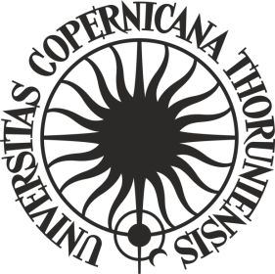**RESOLUTION No. 64**

**of the Senate of the Nicolaus Copernicus University in Toruń**

of 28 May 2019

**on the introduction of framework curricula in doctoral schools**

Pursuant to art. 28.1.12 and art. 201.3 and art. 201.4 of the Act of 20 July 2018 – Law on Higher Education and Science (Dz. U. of 2018, item 1668 as amended) in connection with art. 291 of the Act of 3 July 2018 - Provisions implementing the Act – Law on Higher Education and Science (Dz. U. of 2018, item 1669 as amended)

**I t i s r e s o l v e d** as follows:

Article 1

Framework curricula for the following doctoral schools shall be established:

1. Humanities, Theology and Arts of the Nicolaus Copernicus University in Toruń in the fields of humanities, theology and arts for the disciplines: archeology, philosophy, history, linguistics, literary studies, art sciences, theological sciences, fine art and conservation of works of art; the framework curriculum constitutes Annex 1 to this resolution;
2. Exact and Natural Sciences of the Nicolaus Copernicus University in Toruń in the field of exact and natural sciences for the disciplines: astronomy, mathematics, biological sciences, chemical sciences, physical sciences, Earth and environment sciences; the framework curriculum constitutes Annex 2 to this resolution;
3. Medical and Health Sciences run in the Ludwik Rydygier Collegium Medicum of the Nicolaus Copernicus University in Toruń in the field of medical and health sciences for the disciplines: pharmaceutical sciences, medical sciences, health sciences; the framework curriculum constitutes Annex 3 to this resolution;
4. Social Sciences of the Nicolaus Copernicus University in Toruń in the field of social sciences for the disciplines: economy, finance, social communication and media studies, political science and administration, management and quality studies, legal sciences, sociological sciences, pedagogy; the framework curriculum constitutes Annex 4 to this resolution;
5. Academia Copernicana of the Nicolaus Copernicus University in Toruń in the field of humanities, medical and health sciences, exact and natural sciences, social sciences, theological sciences, and the arts; the framework curriculum constitutes Annex 5 to this resolution.

Article 2

The resolution becomes effective as of 28 May 2019.

**President of the Senate**

**Prof. dr hab. Andrzej Tretyn**

**R e c t o r**